RUNTIME TERROR
Course Name: Data Structures and Algorithms (SE-451)
Instructor Name: Ms Farheen Faisal
Institution Name: DCS/UBIT, University of Karachi
Submitted By:
B2410106003 Abdullah Khalid
B2410106007 Ahsan Zaheer Sheikh
B2410106009 Ammar Ahmed
B2410106027 Kaaif Ahmed Khan
B2410106030 Arham Rehan
B2410106035 Muhammad Hamza
B2410106037 Haris Jawaid
Submission Date: 5 April 2026

1. Introduction
Runtime Terror is a 2D infinite runner game developed using C++ and the Raylib library, themed around a VS Code editor environment. It was created to demonstrate the application of data structures in game development, particularly in implementing mechanics like time rewind and dynamic level generation, without relying on heavy commercial engines. The game solves the challenge of creating an engaging, replayable experience where users can practice game logic and physics while confronting bugs as tangible obstacles. Data structures are crucial here as they manage game state, handle rewind functionality, and store leaderboard data, ensuring smooth gameplay and persistent high scores without performance bottlenecks.

2. Project Idea
A 2D Platformer / Infinite Runner Game System named Runtime Terror.The project serves as an entertaining game, with the goal to survive as long as possible by avoiding errors, compiling successfully generated code lines, and using time-manipulation abilities to avoid game-ending bugs. The player controls an execution pointer, that automatically runs to the right across procedurally generated code tiles. It is like an endless platformer where you jump on code lines, collect power-ups, and rewind time using Ctrl+Z to correct mistakes, all themed as programming in VS Code.

3. Project Description
System features:
- Infinite Runner Mechanics: Procedurally generated tiles that scroll horizontally
- Rewind System: Time reversal using Ctrl+Z for up to 5 seconds
- Multiple Tile Types: Normal (green), Logical (blue), and Syntax Error (red) tiles
- Pickup System: Collectible items that provide bonuses
- Leaderboard: Top 10 scores with persistent storage
- UI System: VS Code-themed menus, pause screen, and game over screen
- Audio System: Background music and sound effects
Working process:
The game initializes a Raylib context, loads visual/audio assets, and enters a continuous game loop. Tiles continuously spawn to the right and move left at a constant speed. In each frame, it parses user input, updates physics, checks for collisions, handles time rewinding if triggered, and renders all objects. The game ends when the player falls off the screen or hits a syntax tile.
Input and output:
- Input: Keyboard controls (SPACE for jump, CTRL+Z for rewind, ESC for pause, mouse for menus)
- Output: Visual rendering of VS Code-themed interface, tiles, player, HUD showing lines compiled, time, and rewind meter; audio feedback for actions
Real-world application:
This project demonstrates practical applications of data structures in entertainment software and simulation systems. The rewind buffer could be adapted for undo systems in text editors or version control, while procedural generation techniques apply to content creation tools or simulation software.

4. Data Structures Used
1. Circular Buffer (RewindBuffer)
- Why it is used: Implements the "Ctrl+Z" time-rewind gameplay mechanic efficiently with fixed memory usage, avoiding extreme memory reallocation costs during heavy physics processing.
- Where it is used in project: Inside rewind.h to store the history of the player's positions over a limited trailing timespan.
2. Linked List (LeaderboardLinkedList)
- Purpose: Maintains a sorted, persistent sequence of top-performing player scores and ranks.
- Function in system: Used in leaderboard.h / leaderboard.cpp to store the top 10 runs. It uses insertion sort to maintain order when new scores are added.
3. Dynamic Arrays (std::vector)
- Role in project: Manages dynamic, ordered lists of game objects whose sizes change unpredictably.
- Where it is used in project: Utilized heavily in main.cpp and tiles.h for managing collections like std::vector<Tile*> for terrain/collisions, std::vector<Pickup> for collectible items, and std::vector<FloatingText> for score popups.
Additional Data Structures Implemented:
- Enum (GameState, TileType): For strict state management and tile categorization.
- Struct (PlayerState, RunDataNode): Core data containers grouping variables for the rewind history and leaderboard tracking.
- Singleton Pattern (LeaderboardManager): Design pattern for centralized, globally accessible leaderboard access.

5. System Design
Modules of System
- Core Game Loop: Handles main update/draw cycle in main.cpp
- Player Module: Manages player physics, input, and state (player.cpp)
- Tile System: Procedural generation and collision (tiles.cpp)
- Rewind System: Time manipulation mechanics (rewind.h)
- UI System: Screen management and rendering (ui_system.cpp, screens.cpp)
- Leaderboard: Score tracking and persistence (leaderboard.cpp)
- Pickup System: Collectible spawning and effects (pickup.cpp)
Main Functions
- Game::Init(): Initializes resources and systems
- Game::Update(): Handles game logic and state transitions
- Game::Draw(): Renders all game elements
- RewindBuffer::Record() / Rewind(): Manages time rewind
- LeaderboardLinkedList::Insert(): Maintains sorted leaderboard
Flow of Program
- Initialize window, audio, fonts, and textures
- Load UI screens and set up callbacks
- Enter main game loop
- Update based on current game state (menu/playing/paused/etc.)
- Handle input, update game objects, check collisions
- Render current screen
- Repeat until quit condition met
- Cleanup resources
System Architecture & Relationships:
- Manager Pattern: UIScreenManager dictates rendering logic and handles screen switching.
- Buffer Recording Cycle: Every frame, the Player module sends coordinate data to the Rewind System to be captured.
- State Machine Diagram:
[MENU] <--> [PLAYING] <--> [PAUSED]
↳ [GAME OVER] --> [LEADERBOARD] ↲

6. Algorithm
Step-by-step procedure:
- Start: Initialize Window, Raylib Context, and configure the main Game class.
- Initialize data structures: Pre-allocate the RewindBuffer circular vector based on memory limits, initialize dynamic arrays for Game Tiles, and load the Linked List Leaderboard from local disk storage.
- Perform operations:
  - Parse keyboard input to apply gravity and trajectory logic to Player.
  - Tile Generation Algorithm: Evaluate player position vs. screen space; spawn new tiles logically when calculated space demands it.
  - Collision Detection Algorithm: Run AABB (Axis-Aligned Bounding Box) checks iteratively between the player bounding box and tile vectors.
  - Score Calculation: Accumulate points based on tile types successfully landed on and lines successfully compiled.
  - Rewind Algorithm: Write the current frame's state to the Circular Buffer. If "Ctrl+Z" is pressed, wrap the head pointer backward, pop historical states, and override current player coordinates.
- Display output: Render textual HUD elements (Status bar with Ln/Col tracking), UI layers, floating score systems, and textures cleanly to the screen.
- Stop: De-allocate dynamically instantiated classes, clear list memory, and close the application environment safely when the quit condition is met.

7. Implementation (Code)
Below are the core implementations of the primary data structures and system logic used to drive the game mechanics:
Core Rewind System (Circular Buffer)
class RewindBuffer {
private:
std::vector<PlayerState> buffer;
int head; // Where to write the next state
int count; // How many states are currently stored
int capacity; // Maximum frames to be stored

public:
RewindBuffer(int cap) {
capacity = cap;
buffer.resize(capacity);
head = 0;
count = 0;
}

// Called every frame during normal gameplay to record history
void Record(PlayerState state) {
buffer[head] = state; // Write data to the buffer dynamically
head = (head + 1) % capacity; // Uses modulo to wrap around array end
if (count < capacity) count++;
}

// Called every frame when the player holds 'Ctrl+Z'
bool Rewind(PlayerState &outState) {
if (count == 0) return false;

// Push the pointer backwards chronologically
head = (head - 1 + capacity) % capacity;
outState = buffer[head];
count--;

return true;
}
};
Leaderboard Linked List
class LeaderboardLinkedList {
private:
RunDataNode* head;
int count;
int maxSize;

public:
void Insert(RunDataNode* newNode) {
// Insert in sorted order by score (Insertion Sort logic)
if (!head || newNode->score > head->score) {
newNode->next = head;
head = newNode;
} else {
RunDataNode* current = head;
while (current->next != nullptr && current->next->score >= newNode->score) {
current = current->next;
}
newNode->next = current->next;
current->next = newNode;
}

if (count >= maxSize) RemoveLast();
count++;
UpdateRanks();
}
};
Tile Management & Procedural Spawning
void Tile::New_tiles(std::vector<Tile *> &tiles, float scrollSpeed) {
// Spawn new tiles based on game progress and screen space
int required = CalculateRequiredLeftTiles(tiles, scrollSpeed);
for (int i = 0; i < required; i++) {
// Pushes new dynamically generated tiles to the back of the vector array
tiles.push_back(new Tile(TILES_START_X + i * TILE_SPACING, GetMaxTileWidth(), GetRandomTileType()));
}
}

8. Output
- Main Menu Screen: Displays a customized VS Code layout with a sidebar. Inside the welcome page, the game menu is displayed.
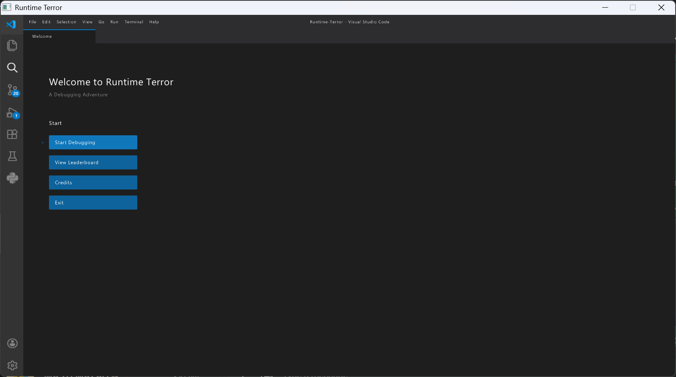
- Gameplay Output:
The player (a blinking cursor block) traverses code blocks, with normal code blocks and erroneous code blocks (colored as red for runtime errors, and blue for logical errors). Orange pickups to recharge memory buffer (rewind), and a VS Code themed HUD.
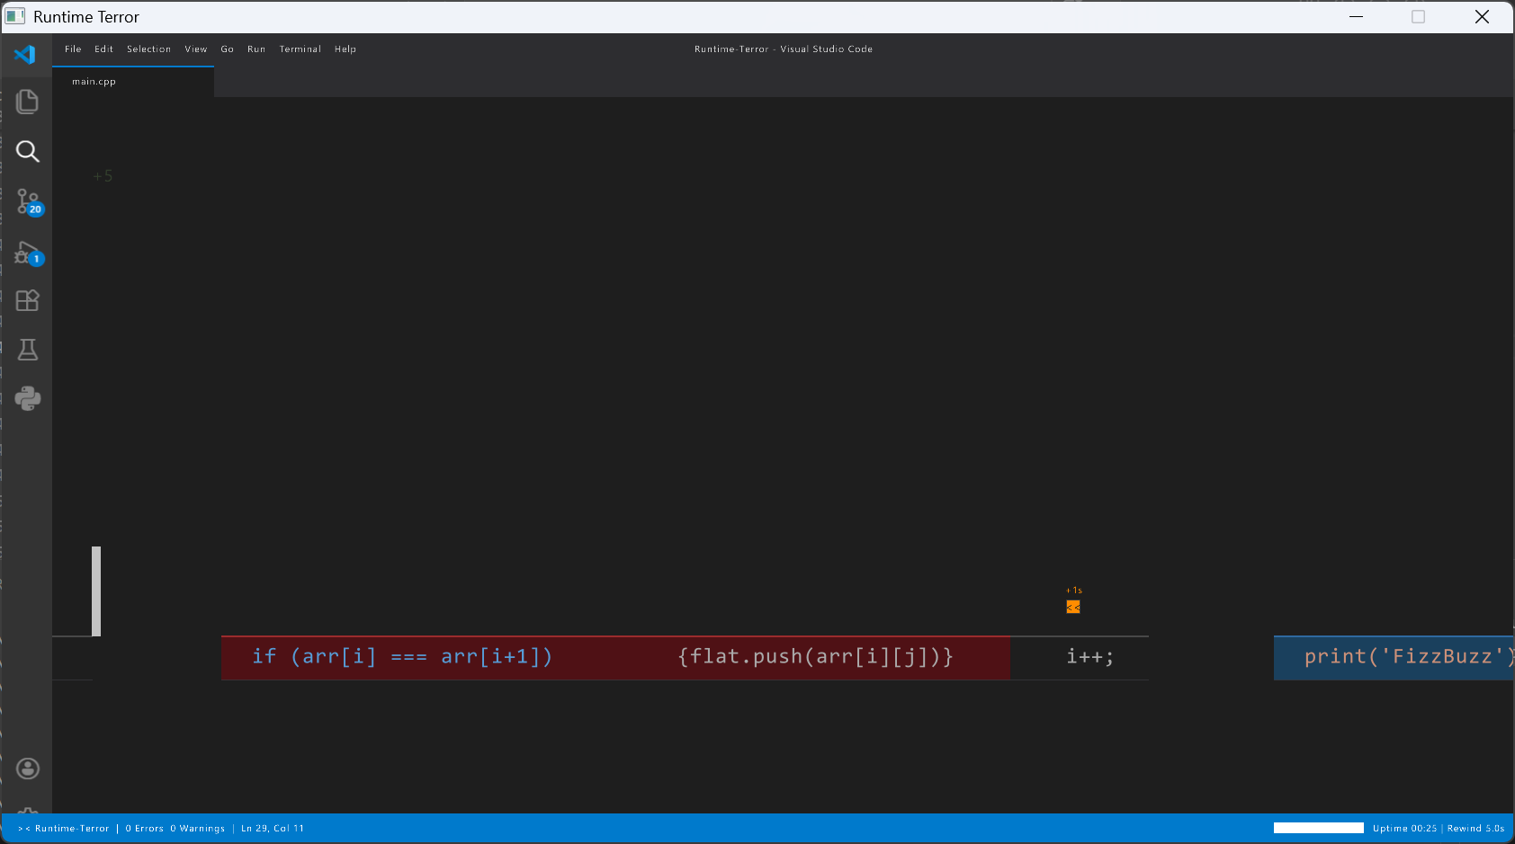
- Game Over Screen: A terminal styled game over screen.
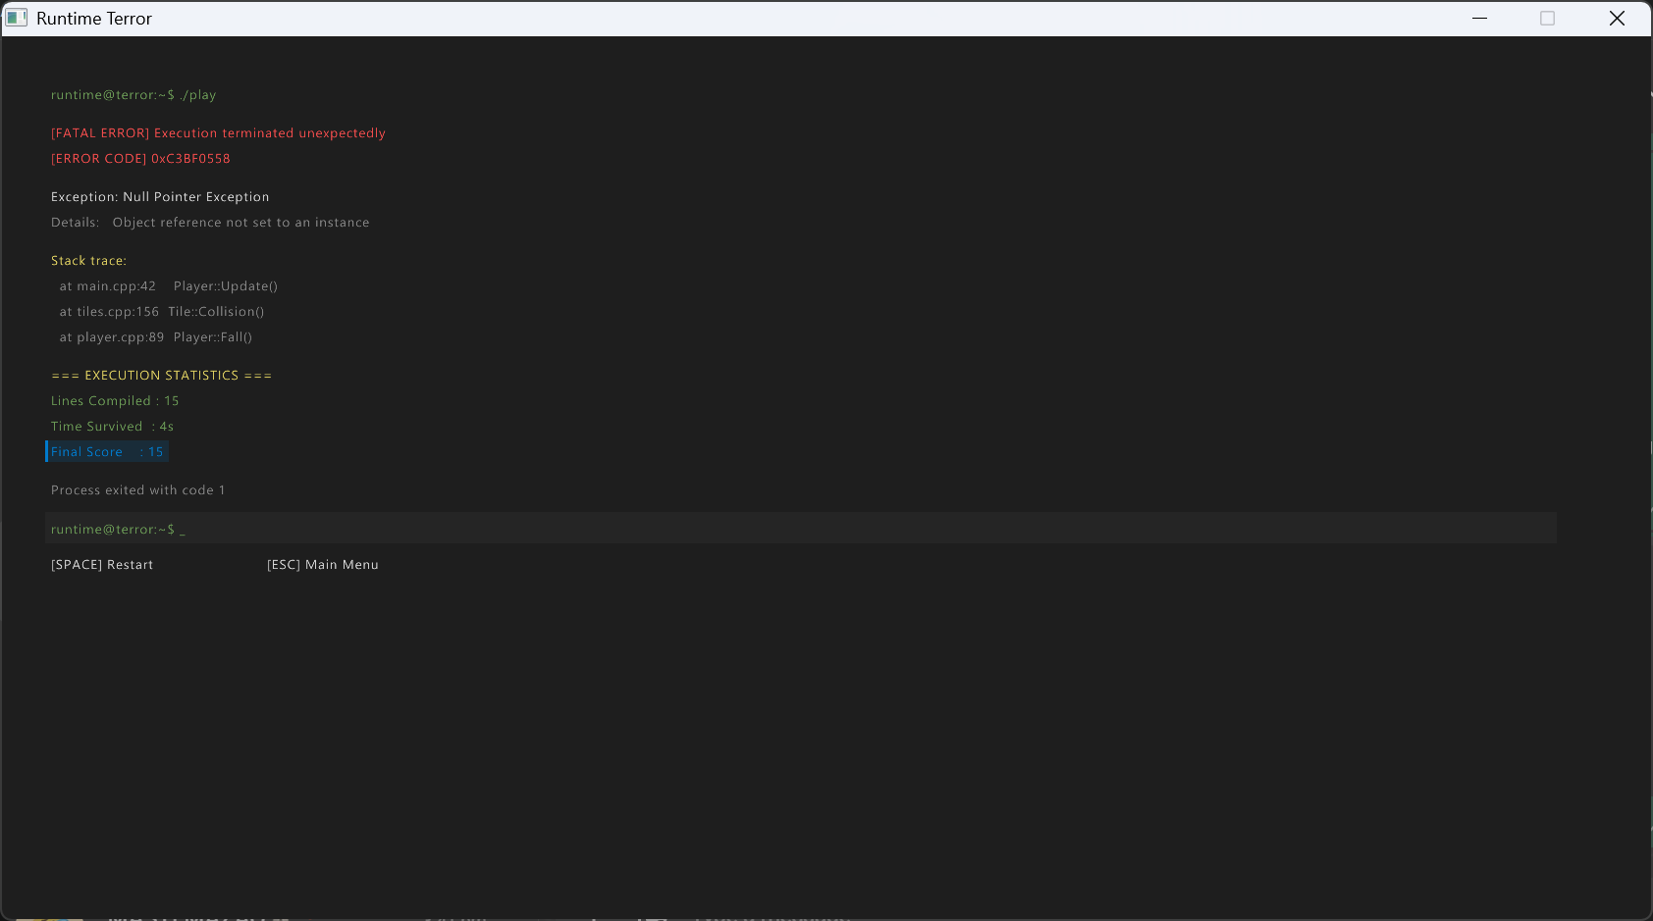
Leaderboard Screen: A spreadsheet styled leaderboard.
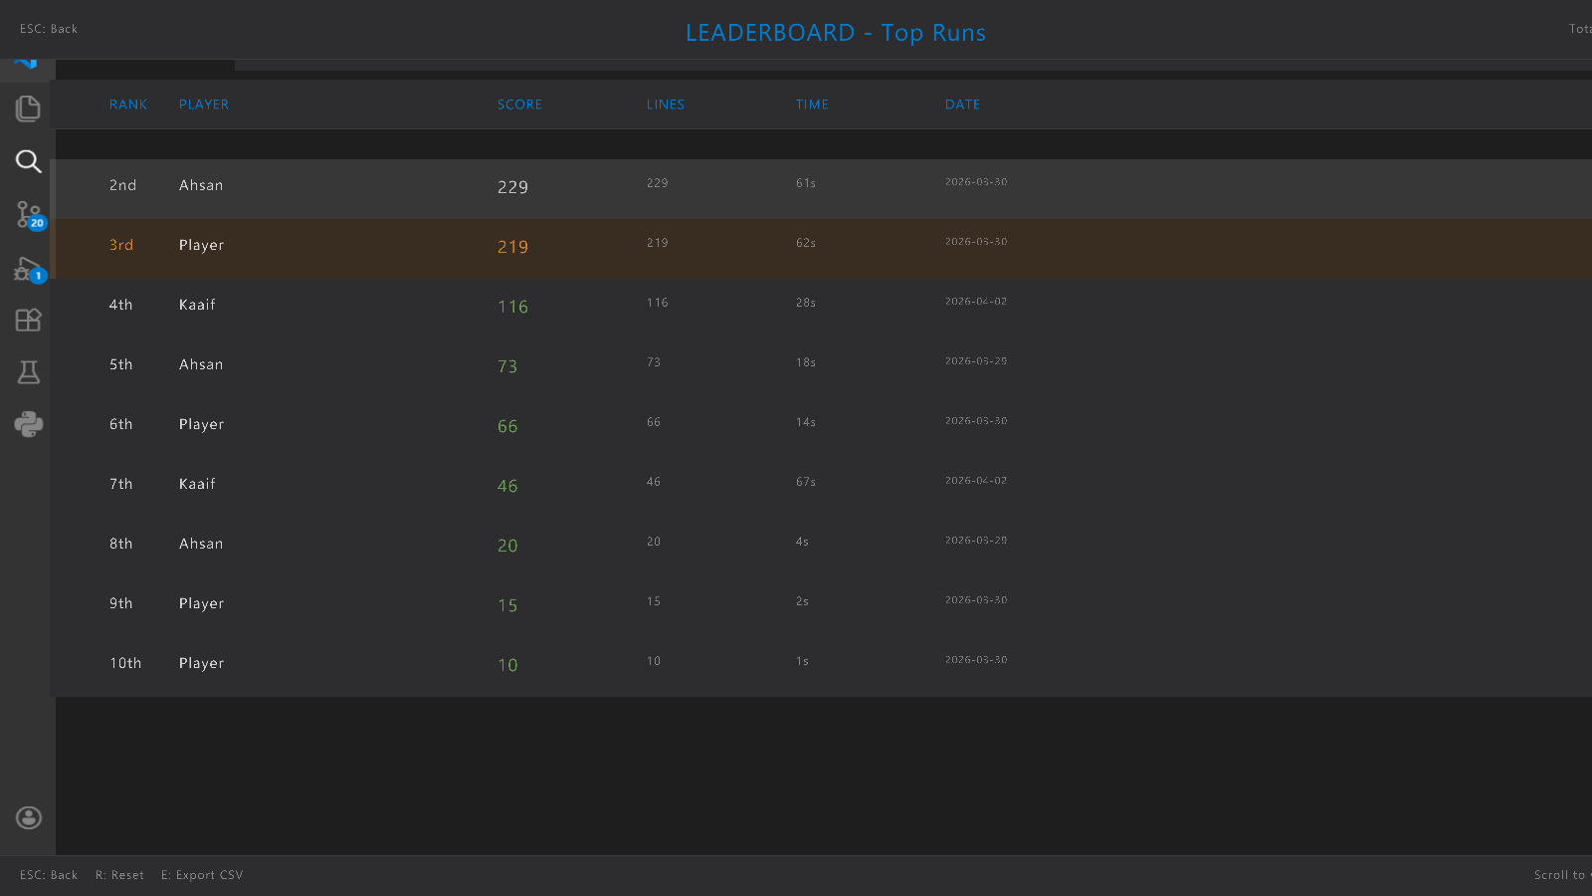

9. Advantages
- Improves efficiency: The specialized use of a circular buffer avoids extreme O(n) memory reallocation costs during heavy physics processing, providing O(1) rewind operations.
- Uses multiple data structures: Smoothly incorporates Linked Lists, Dynamic Arrays, and Circular Buffers into a single environment to solve different engineering problems efficiently.
- Real-life application: The rewind mechanics implemented here are the exact foundational concepts used for "Undo" systems in text editors and version control state-tracking.
- Enhances teamwork: The decoupled structure (headers vs. source decoupling) ensures designers, audio technicians, and programmers can collaborate modularly on different systems simultaneously.
- Improves programming skills: Strictly challenges core C++ competencies, pointer memory management, game architecture patterns, and algorithm structuring outside of commercial safety-net game engines.

10. Conclusion
Through developing Runtime Terror, our group gained concrete exposure to deploying game loop algorithms, mapping abstract real-time memory handling paradigms, and applying physics systems within C++. We learned the practical importance of choosing appropriate data structures for specific use cases. The circular buffer proved essential for the rewind mechanic, enabling 'Time-Reversal' in constant-time without frame dropping. Linked lists were perfect for the leaderboard system, allowing clean insertion and sorting bypassing unnecessary tree-heap logic. This project demonstrates how data structures form the foundation of efficient software systems, proving that complex, highly optimized mechanics and a professional-tier aesthetic can be built from scratch while making learning highly engaging.

11. References
- Official Raylib 5.0 Documentation & Cheat Sheet (https://www.raylib.com/)
- W3 Schools (https://www.w3schools.com/cpp/)
- Microsoft VS Code Documentation (For authentic UI color scheme mapping)

